## **Chatbot Deployment With IBM Cloud Watson Assistant**

Development-1

## 

Chatbot Deployment with IBM Cloud Watson Assistant

Creating a Watson Assistant involves several steps. Here's a general overview:

**Sign Up for IBM Cloud:**

If you don't have an IBM Cloud account, you'll need to sign up for one at [IBM Cloud](https://cloud.ibm.com/).

**Access Watson Assistant:**

After signing in, go to the IBM Cloud dashboard.

**Create a Watson Assistant Service**:

Click "Create Resource."

Search for "Watson Assistant" in the catalog and select it.

Choose the pricing plan that fits your needs.

**Service Configuration:**

Give your service a name.

Choose the region for your service.

Click "Create" to provision the Watson Assistant service.

**Create an Assistant:**

Once the service is provisioned, click on it.

Under "Manage," click "Launch Watson Assistant."

**Create a Skill:**

Inside Watson Assistant, create a new skill. A skill represents a chatbot or virtual assistant.

Configure your skill by defining intents, entities, and dialog flows.

**Train Your Assistant:**

Teach your assistant by adding examples for each intent and setting up

dialog nodes for conversatons.

**Integration:**

Decide how you want to integrate your assistant. You can integrate it into a website, mobile app, or other platforms.

**Test and Refine:**

Test your assistant to make sure it understands user queries and responds

accurately. Refine your training data and dialog as needed.

**Deploy Your Assistant:**

Once you're satisfied with your assistant's performance, deploy it to the

platform where you want it to be used.

**Continuous Improvement:**

Regularly monitor the performance of your assistant and gather user

feedback to improve it over time.

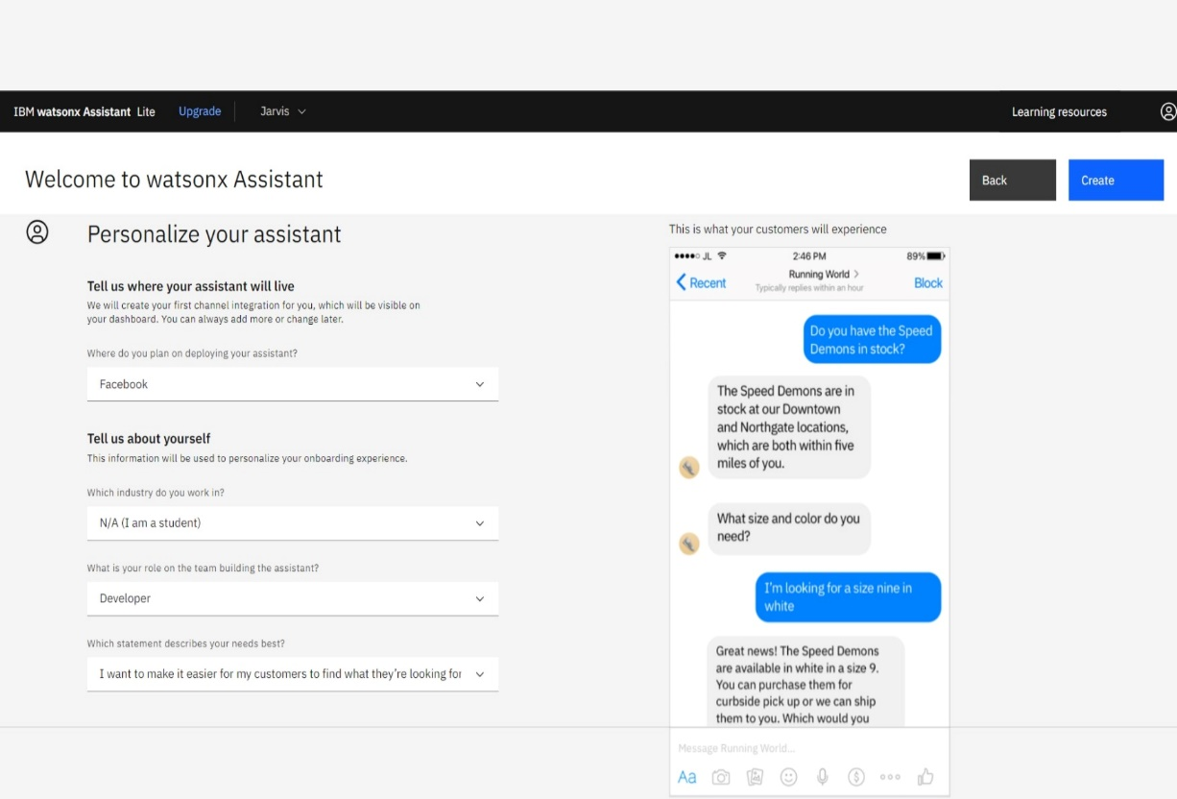

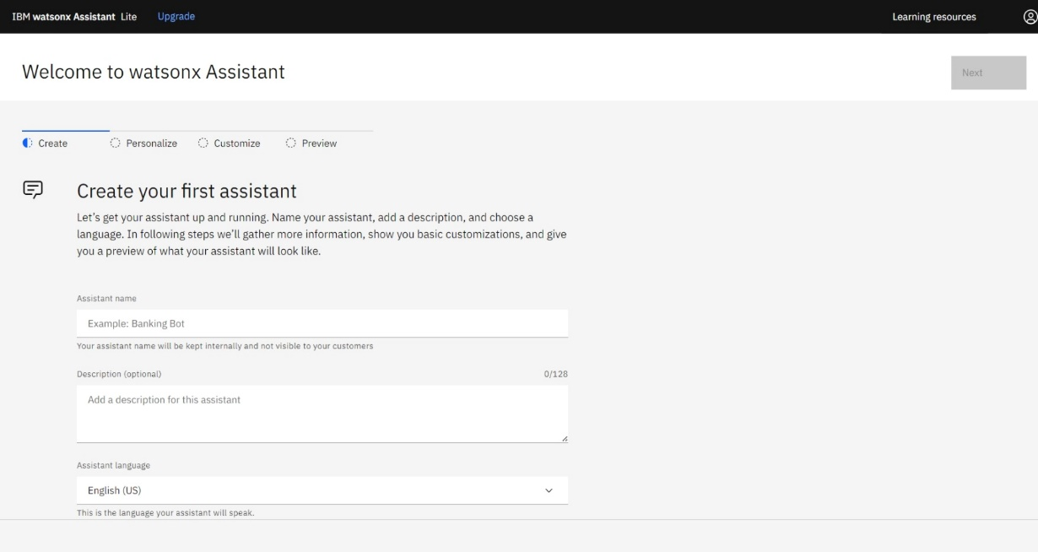

**Log in to IBM Cloud:**

Go to the IBM Cloud website and log in to your account.

**Navigate to Resource Groups:**

Once logged in, click on the "Resources" section in the IBM Cloud Console.

**Create a New Resource Group:**

In the Resource Groups section, you should find an option to create a new resource group. Click on it.

**Actions:**

Actions are used to define custom logic or to trigger specific behaviors in response to user input. They can involve setting context variables, generating responses, or making external API calls.

Actions are custom code or logic that the chatbot can execute in response to user input. This might involve making API calls, modifying context variables, or other custom behavior.

#### EXAMPLE CONVERSATION OF CHATBOT IN FACEBOOK MESSENGER

**User:**

Hi, I need to change my Facebook password. Can you guide me through the

process?

**Chatbot:**

Absolutely, I can help with that. To change your password, you'll need to follow these steps:

* Open the Facebook app on your device.
* Tap the three horizontal lines in the bottom-right corner to access the menu.
* Scroll down and select "Settings & Privacy."
* Tap "Settings."
* Scroll down to the "Security" section and tap "Security and Login."
* Under "Login," you'll find an option to "Change password." Tap on it.

**User:**

Got it, I've reached the "Change password" option.

**Chatbot:**

Great! Now, you'll be prompted to enter your current password for verification.

Please enter your current password.

**User:**

Password entered.

**Chatbot:**

Perfect. Now, you can set your new password. Be sure to choose a strong and

unique one. Once you've entered it, confirm it by typing it again.

**User:**

New password set and confirmed.

**Chatbot:**

Fantastic! Your password has been changed successfully. You should receive a

confirmation message. Is there anything else you'd like assistance with?

**User**:

No, that's it. Thanks for your help!

**Chatbot:**

You're welcome! If you have any more questions in the future, don't hesitate to

reach out. Have a great day!

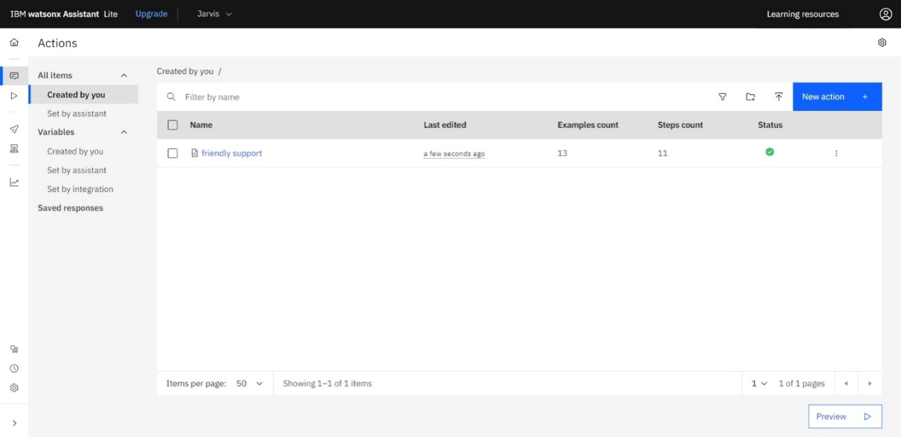

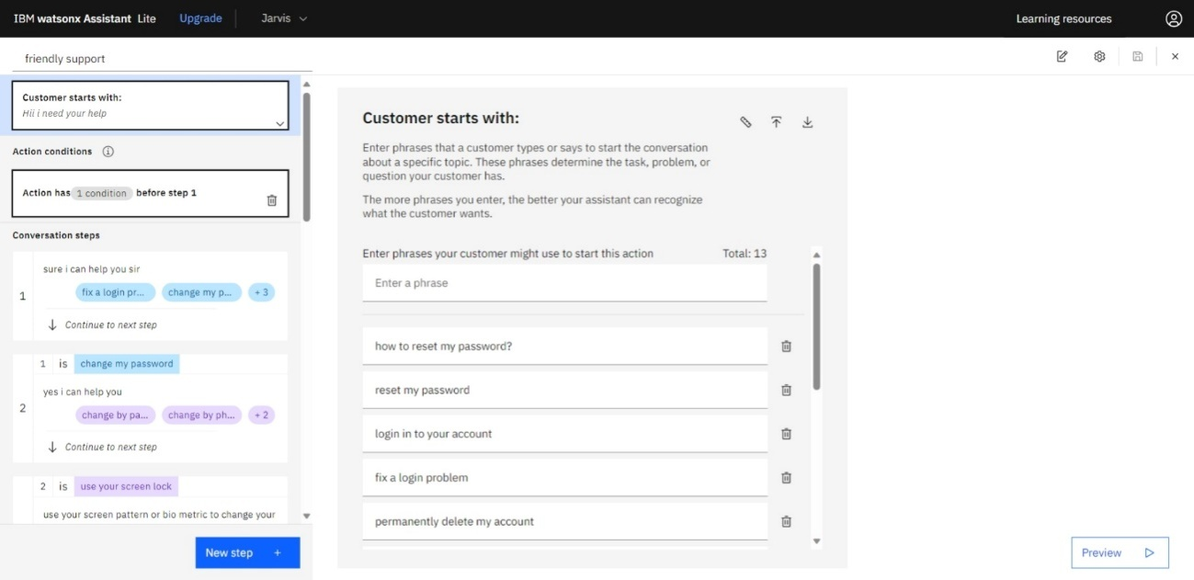

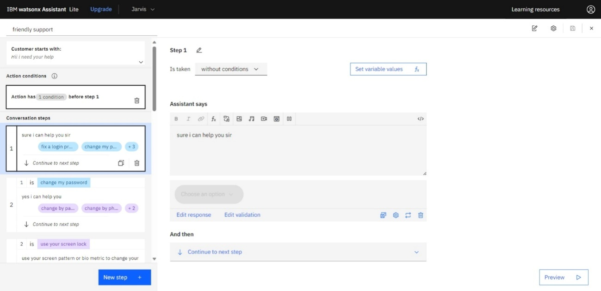

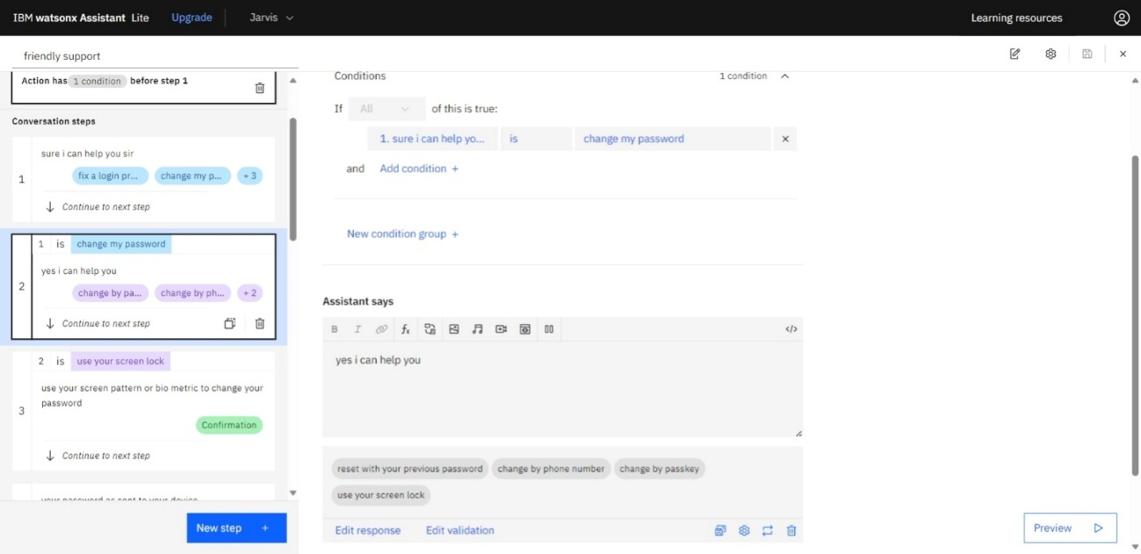

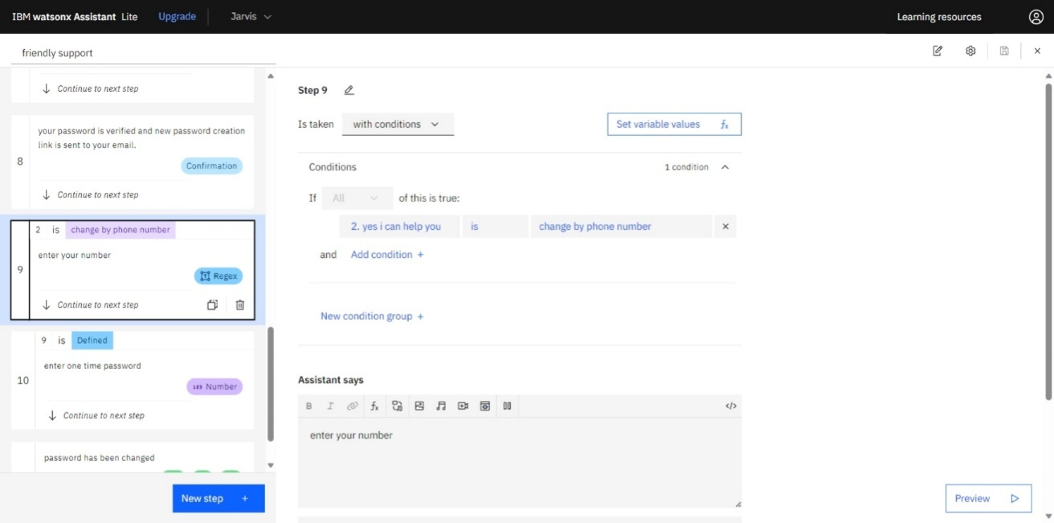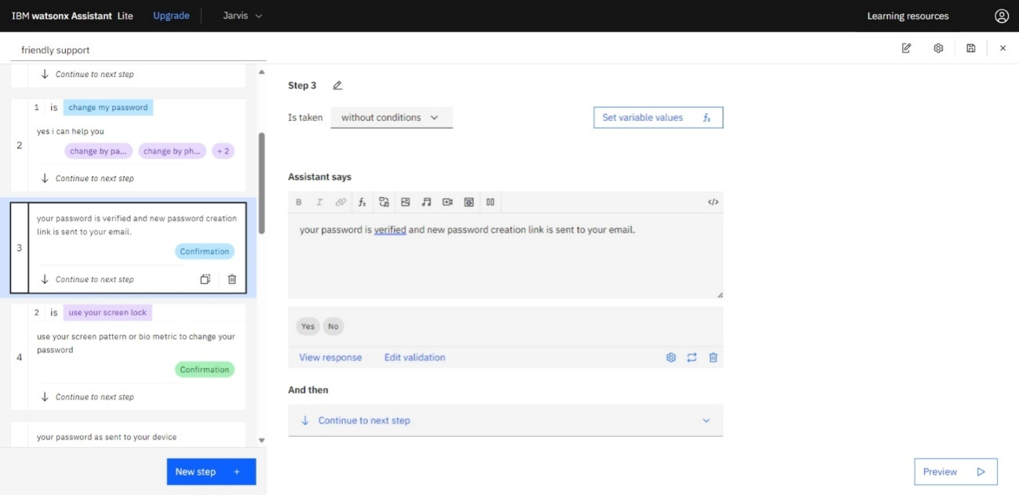

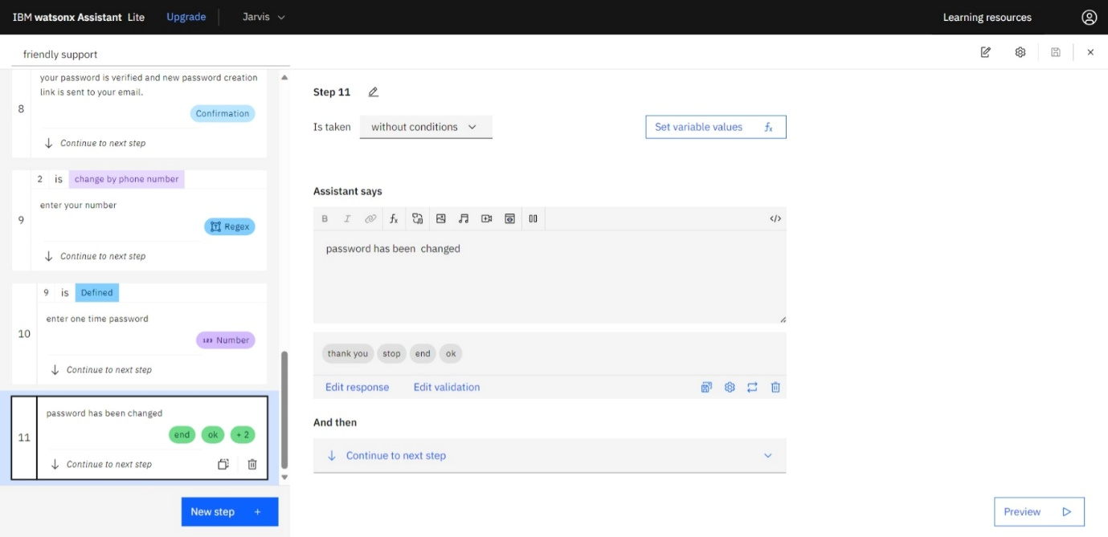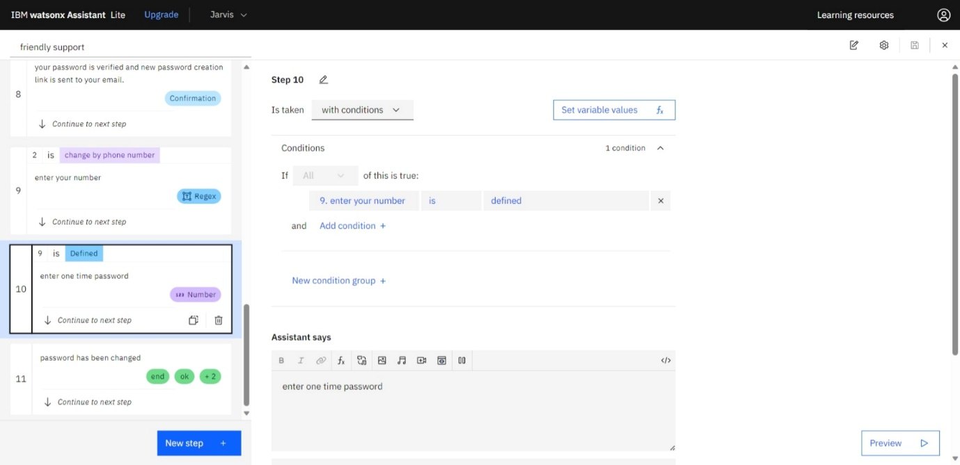

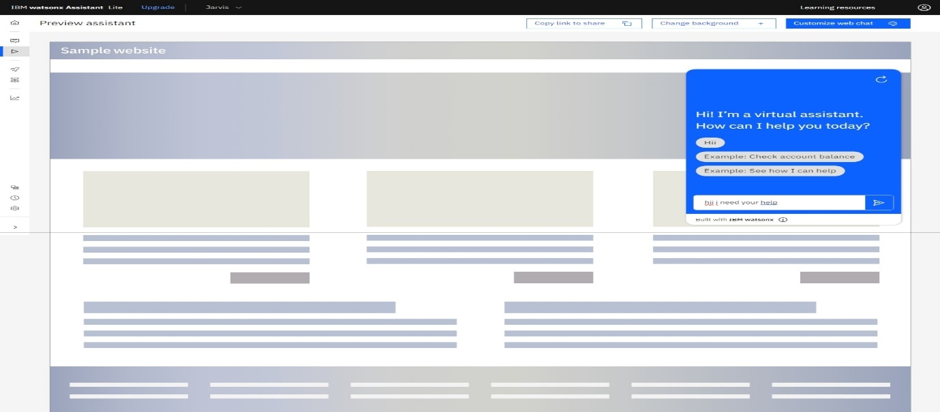

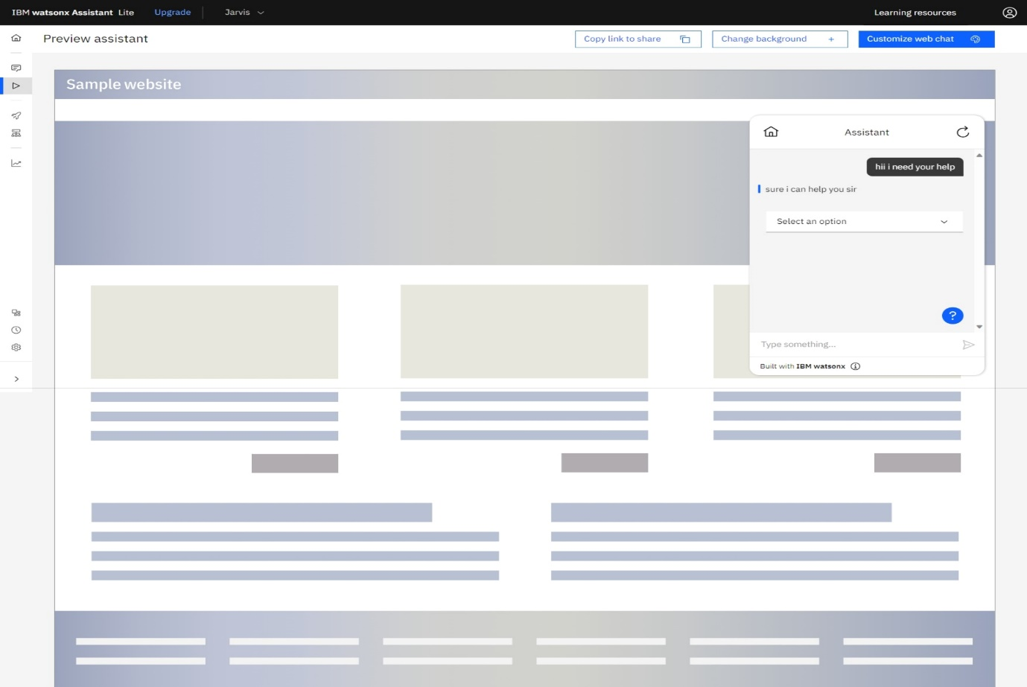

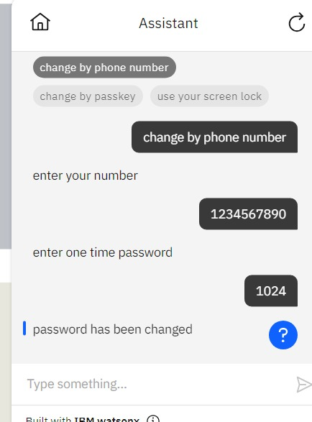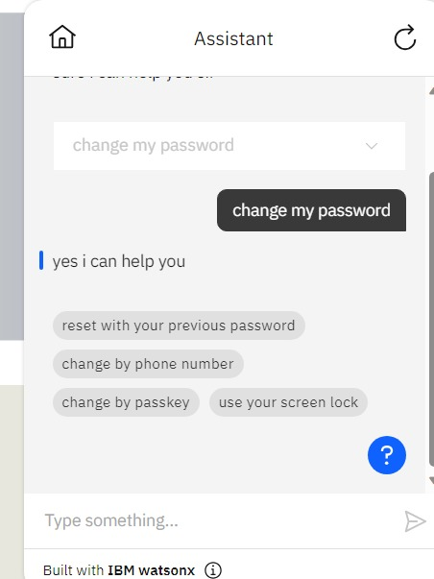

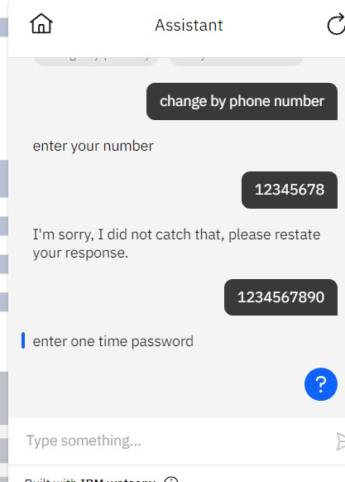

# Intents

In Watson Assistant, "intents" are a fundamental concept used to understand the meaning or purpose behind a user's input. They help the chatbot recognize what a user is trying to accomplish or the main topic of their message. Here's how intents work in Watson Assistant:

**Intent Recognition:**

When a user sends a message to the chatbot, Watson Assistant's natural language processing capabilities analyze the text to identify the user's intent. This intent recognition is based on the patterns and keywords present in the user's message.

**Intent Definitions:**

You, as a developer, define a set of intents that are relevant to your chatbot's domain or purpose. For example, in a weather chatbot, you might define intents like "get_weather," "check_forecast," "ask_temperature," etc.

**Training Data:**

To train the chatbot to recognize these intents, you provide examples of user messages for each intent. These examples are used to teach Watson Assistant's machine learning models to associate certain phrases and patterns with specific intents.

**Intent Confidence:**

For each user message, Watson Assistant not only identifies the intent but also provides a confidence score. This score indicates how certain the chatbot is that it correctly recognized the user's intent. You can use this confidence score to make decisions in your dialogue nodes.

**Dialog Flow:**

Once the intent is recognized, you can use it to guide the conversation flow. Depending on the detected intent, you can route the conversation to different dialogue nodes or provide appropriate responses.

**Fallback Intent:**

You can define a "fallback" intent to handle situations where the chatbot cannot confidently identify any other intent. This allows you to gracefully respond to user messages that are outside the scope of defined intents.

**Context Management:**

Intents often work in conjunction with entities and context variables to provide context-aware responses and gather necessary information from the user.

# Entities

**1. Recognition of Structured Information:**

Entities are used to identify and extract structured data from user messages. This structured data can be specific details such as dates, times, numbers, locations, product names, or any other relevant information.

**2. Entity Types:**

Watson Assistant supports various entity types, including system entities and user-defined entities. System entities are predefined for common concepts like numbers, dates, and times, while user-defined entities are created to match domain-specific data.

**3. Training Data:**

To teach the chatbot to recognize entities, you provide training data that includes examples of user messages containing the entities you want to extract. For instance, if you're building a chatbot for ordering pizza, you might create an entity called "PizzaTopping" and provide training examples like "I want a pizza with pepperoni."

**4. Entity Values:**

Within an entity type, you define entity values. For example, if you have an entity type "PizzaTopping," the entity values could be "Pepperoni," "Mushroom," and "Onion." These values represent the specific options that the chatbot should recognize within the entity.

**5. Entity Matching:**

When a user sends a message to the chatbot, the platform uses natural language processing to analyze the message and identify which entity values are present. For instance, if a user says, "I'd like a pizza with pepperoni and mushrooms," the chatbot might recognize the "PizzaTopping" entity with the values "Pepperoni" and "Mushroom."

**6. Contextual Data:**

Extracted entities are used to provide context and assist the chatbot in generating relevant responses. In the pizza example, the chatbot can use the identified pizza toppings to accurately fulfill the user's order.

**7. Multiple Entities:**

In a single message, users may mention multiple entities. Watson Assistant is designed to identify and extract multiple entities to enhance its understanding of user input.

# Dialogue

In Watson Assistant, dialogue nodes are essential components that define the flow and interaction of a chatbot with users. They represent specific points in the conversation where the chatbot processes user input and provides responses. Here's how dialogue nodes work:

**Trigger Condition:**

Each dialogue node typically has a trigger condition that specifies when the node

should be activated. For example, a trigger condition might be based on specific user

input or context.

**User Input:**

When the trigger condition is met, the chatbot processes the user's input provided up

to that point in the conversation. It may use natural language processing to understand

the user's intent and entities mentioned.

**Response:**

The dialogue node contains a response that the chatbot will deliver to the user based

on their input. This response can be static text or dynamically generated based on

variables or logic.

**Actions:**

Dialogue nodes can also include actions, such as setting context variables, invoking

external services, or branching to other nodes. These actions help control the

conversation flow.

**Conditions:**

Conditional logic can be used in dialogue nodes to guide the conversation. For

example, you can create conditions based on user input or variables to direct the

chatbot's responses.

**Slots:**

In more complex interactions, slots can be used to gather specific information from the

user, like dates, numbers, or choices.

**Digressions:**

Watson Assistant supports various digressions, allowing the chatbot to handle multiple

topics simultaneously or return to the main conversation flow after addressing a side

topics.

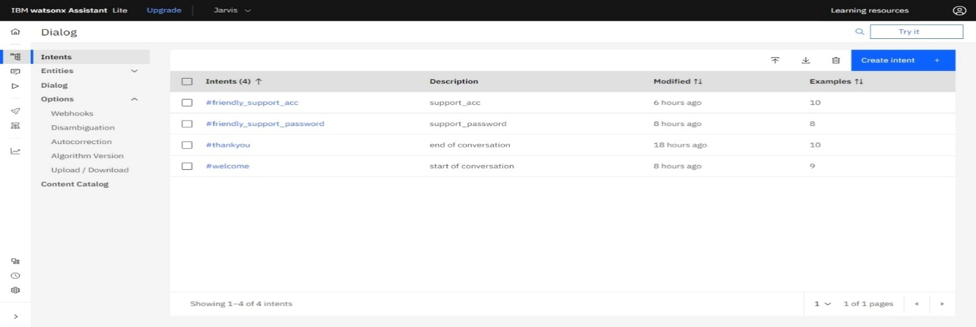

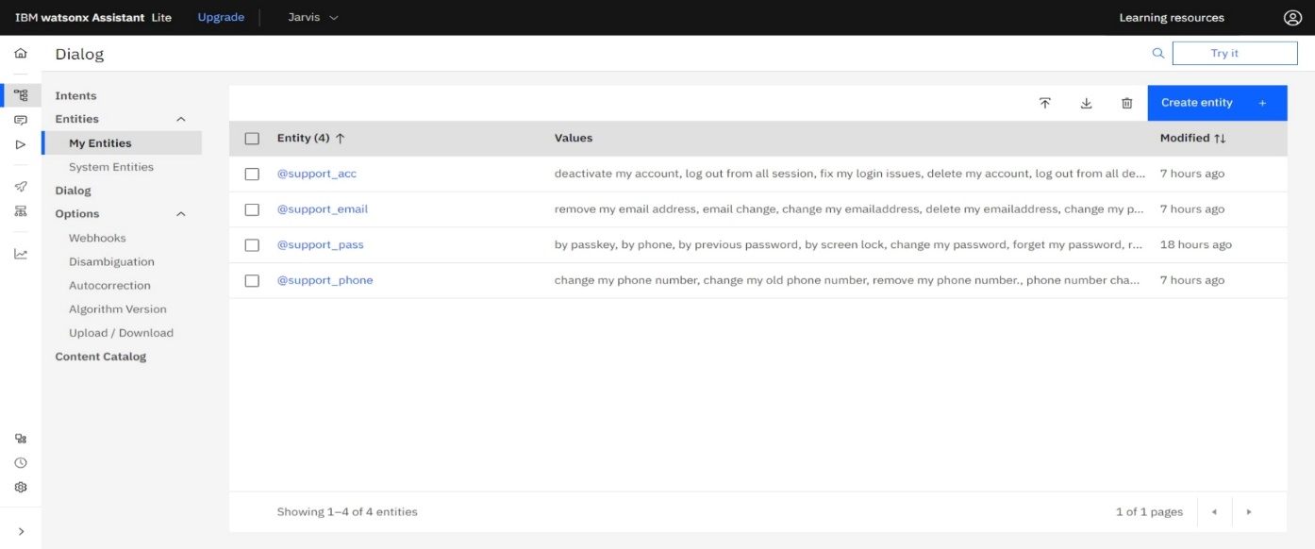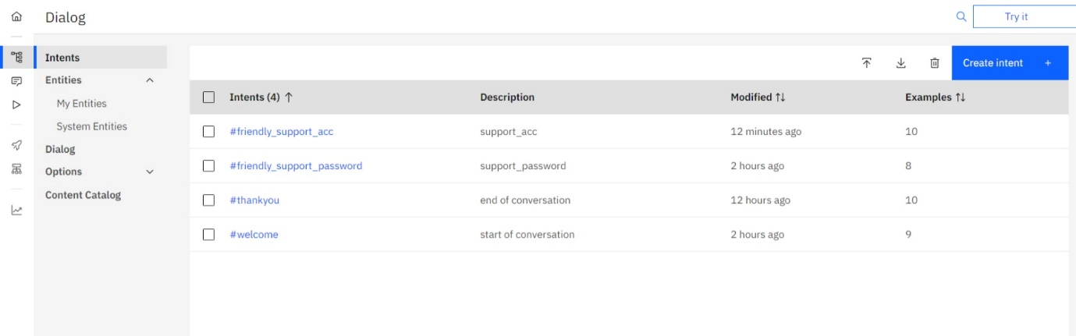k

